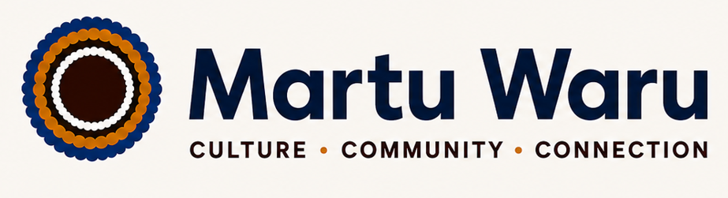
CULTURE • COMMUNITY • CONNECTION
Modern Slavery Act Statement
Reporting Period: 1 July 2025 – 30 June 2026
Entity: Martu Waru
Issued in accordance with: the Australian Modern Slavery Act 2018 (Cth)
1. Introduction
Martu Waru is committed to conducting business ethically, responsibly, and with respect for human rights. This Modern Slavery Act Statement outlines the steps taken by Martu Waru to identify, assess and address the risks of modern slavery and human trafficking within its operations and supply chains.
Modern slavery includes practices such as forced labour, debt bondage, human trafficking, child labour and other forms of exploitation that deprive individuals of their freedom and dignity.
2. Organisational Structure, Operations and Supply Chains
Martu Waru is an Australian-based organisation engaged in building, construction, fabrication, civil and maintenance throughout Western Australia.
Our operations are supported by a network of suppliers and service providers located in Australia and where applicable internationally. Key procurement categories include:
- Professional services
- Goods and materials relevant to operations
- Outsourced contractors and subcontractors
- Technology and administrative services
3. Risks of Modern Slavery Practices
Martu Waru recognises that modern slavery risks may exist in global and domestic supply chains, particularly in:
- Low-skilled labour sectors
- Offshore manufacturing environments
- High-volume procurement categories
- Subcontracted service arrangements
We assess risk based on geography, industry sector and supplier engagement level. At present, the highest potential risks are considered to be in indirect supply chains where visibility is limited.
4. Actions Taken to Address Risks
During the reporting period, Martu Waru has taken the following steps:
- Implemented supplier due diligence processes for new vendors
- Included modern slavery clauses in procurement contracts
- Conducted risk-based supplier reviews
- Encouraged suppliers to comply with ethical labour standards
- Promoted internal awareness of modern slavery risks among staff involved in procurement
5. Assessment of Effectiveness
Martu Waru continues to develop its approach to measuring the effectiveness of its modern slavery risk controls. Current indicators include:
- Supplier compliance with contractual obligations
- Completion of supplier risk assessments
- Internal audit and procurement reviews
- Supplier corrective action completion rates
- Staff training and awareness completion rates
We acknowledge that further refinement of performance metrics is required and will be developed in future reporting periods.
6. Consultation Process
Where applicable, Martu Waru consults with internal departments involved in procurement, finance, and operations to ensure a coordinated approach to identifying and managing modern slavery risks.
If Martu Waru operates with related entities, consultation will also occur across those entities to ensure consistency in risk management practices.
7. Future Commitments
In the next reporting period, Martu Waru intends to:
- Strengthen supplier auditing and verification processes
- Improve traceability in high-risk supply chains
- Enhance reporting and monitoring systems
- Integrate modern slavery risk considerations into supplier onboarding and procurement decision-making processes
- Increase supplier engagement through targeted communication, capacity-building initiatives and corrective action follow-up
- Develop and implement more robust effectiveness measures and key performance indicators to assess the impact of modern slavery risk controls
8. Approval and Signature
This statement has been approved by the board or governing authority of Martu Waru and is signed on their behalf.
Signed: 
Name: Reginia Girgirba
Position: Owner / Director / Managing Director
Date: 18 June 2026

