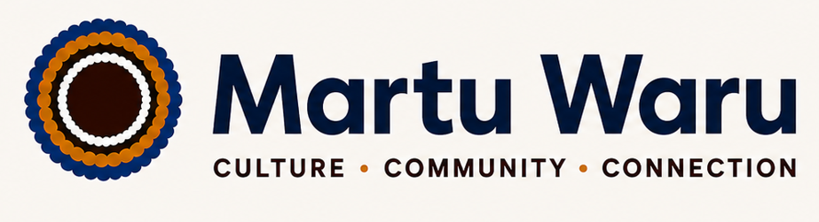
CULTURE • COMMUNITY • CONNECTION
Accessibility Statement
At Martu Waru, we are committed to ensuring that our services, communications, and digital platforms are accessible, inclusive and welcoming to all people, including Aboriginal and Torres Strait Islander peoples, people with disability, older Australians and those from culturally and linguistically diverse backgrounds.
As an Aboriginal-owned construction and building company based in Western Australia, we recognise the importance of accessibility as a core value that reflects respect, equity and cultural responsibility. We strive to create environments both physical and digital that enable full participation in our services and activities.
Our Commitment
Martu Waru is dedicated to:
- Providing accessible and inclusive communication in plain language wherever possible
- Ensuring our workplace and project sites consider accessibility needs in design and delivery
- Supporting clients, partners and community members to access information in formats that meet their needs
- Continuously improving accessibility practices in line with relevant Australian standards and best practice guidelines
Digital Accessibility
We aim to ensure that our website and digital content are accessible to the widest possible audience, including people using assistive technologies such as screen readers, voice recognition software and keyboard navigation. We are committed to ongoing improvements in alignment with the Web Content Accessibility Guidelines (WCAG).
Physical Accessibility
Where applicable to our worksites and project environments, we support and advocate for safe, accessible access for workers, clients and community stakeholders and we work with partners to identify and address accessibility requirements early in project planning.
Feedback and Contact
We welcome feedback on the accessibility of our services. If you experience any barriers or require information in an alternative format, please contact us so we can assist you.
Martu Waru is committed to continuous learning and improvement to ensure accessibility is embedded in everything we do.

